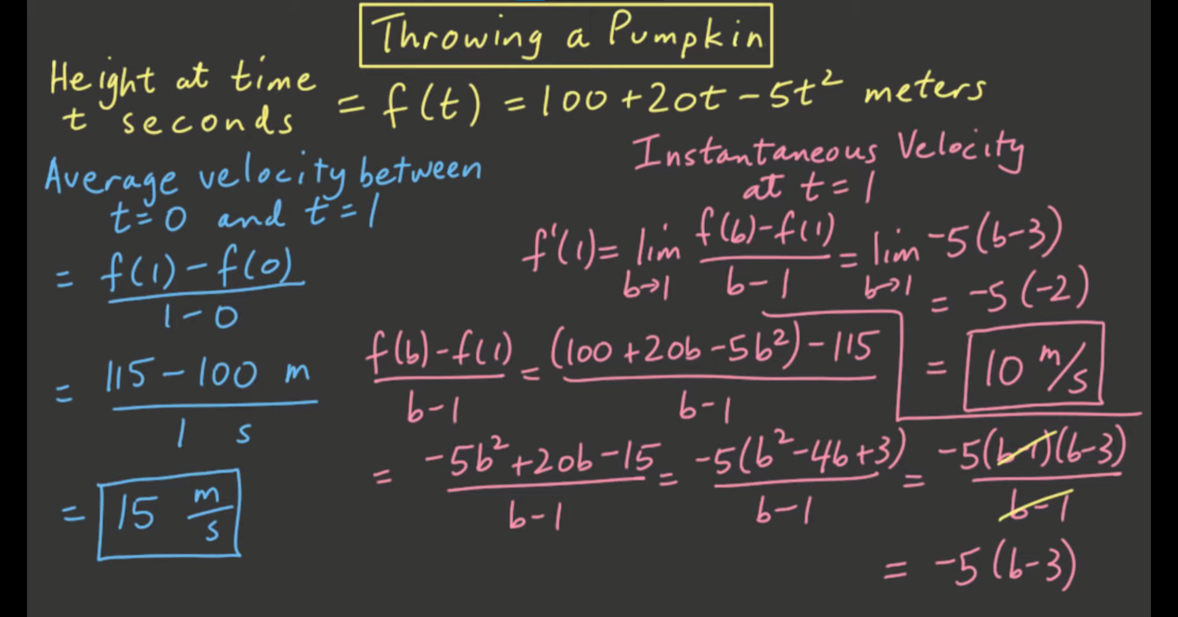

Why are they different?

* Average velocity measure between the time interval
  + Its not at a point, meaning

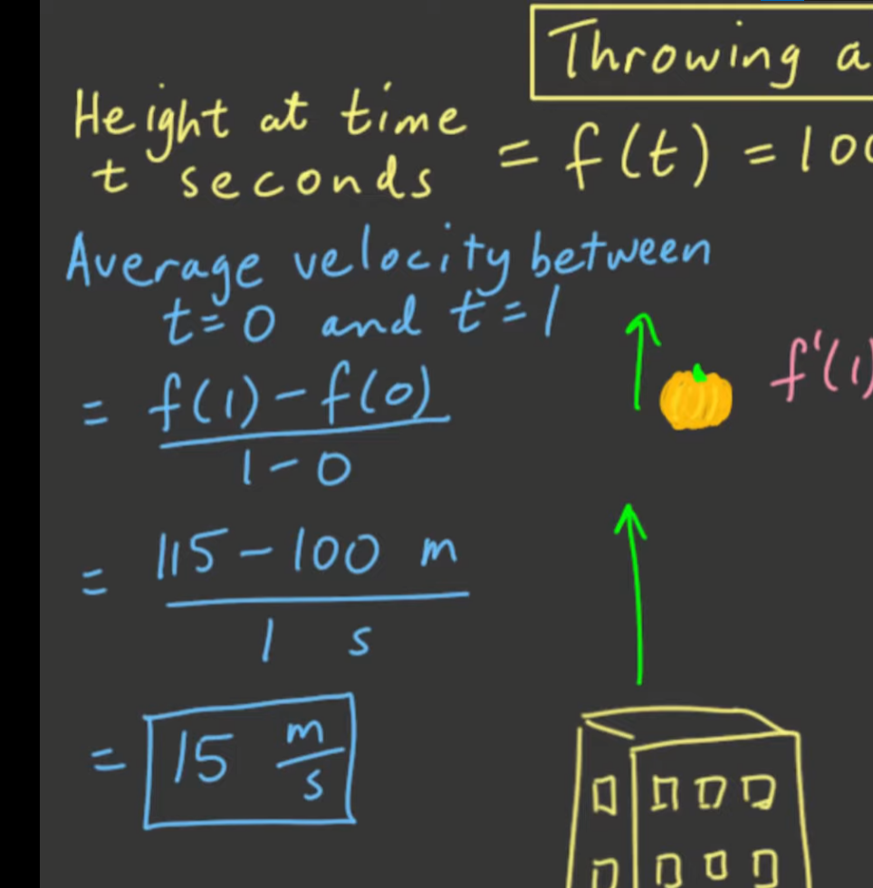

* + - The velocity when t=0 is not equal to the velocity when t = 1
* Instantaneous velocity measure exactly at that point!

